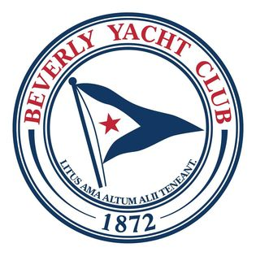

BEVERLY YACHT CLUB
RACE MANAGEMENT GUIDE - 2025
A Guide for Race Committee Members and Trainees

Beverly Yacht Club

Race Management Guide – 2025

Table of Contents Page
About this Guide 1
Safety and Decision to Race 2
Go/No Go Decision 3
On-the-Water Race Committee Assistance
Race Committee Responsibilities 4
Commodores Race Committee Positions 4
Scores Determined by the Race Committee 5
2024 Race Chart 6
Locations of BYC Racing Marks 7
Usages for Portable Marks 9
Common Race Signals/Flags 10
Series Racing Preferences
Tuesday Twilight – Bullseyes and H12s 11
Wednesday Twilight – PHRF Racing 12
PHRF Courses 13
Thursday Ladies’ Racing – Bullseyes and H12s 15
Thursday Twilight – J/80s and Shields 16
Saturday Series - Shields 17
Sunday Series – Bullseyes and H12s 18
Sunday Fall Series – Bullseyes, H12s, Shields 19
Safety Protocol for BYC Club Racing 20
Additional Resources for Race Committee Volunteers: 21
BYC Race Committee
US Sailing
Racing Rules of Sailing
US Sailing Race Management Certification

About this Guide
The purpose of this guide is to outline BYC’s Race Committee safety guidelines, procedures, protocols, and the individual fleets’ racing preferences. It is designed to be the go-to reference for running BYC Series racing aboard Commodores. We hope that this guide serves not only as information for veteran Race Officers, but also, importantly, as a welcoming resource for those who are interested in learning more about what it means to be part of BYC’s on-the-water Race Committee.

An important part of the rich heritage of Beverly Yacht Club is the long history and continuing support of a volunteer Race Committee. If you are an experienced PRO, please consider sharing your knowledge with BYC members who are interested in becoming more involved in race management, because, as they say, “it takes a village” -- and our “BYC village” needs to come together to help ensure that we are adding new race officers, flag signalers, line-sighters, timers, and scribes into our pipeline in order to be able to continue to carry on the great racing BYC has become known for.

To that end, we encourage you to take interested friends aboard Commodores with you, and to instruct them if they are new to racing. Review the start sequence, flags, and signals with them. Include them in your thinking as you select courses. Help them learn how BYC races are run, and why we follow specific procedures. This handbook is a good place to start.

You’ll note that this booklet includes all the information necessary to play with course configurations -- before you even get on the water! Your tools include an accurate race chart and scale, mark descriptions and locations, and a mark bearing/distance chart. You can also review the flags used by Commodores for BYC racing, as well as the different configurations for the drop mark courses. The Race Committee worked hard to create a drop mark course library that would enable the PRO to offer more types of courses to the fleets, including the ability to occasionally utilize offset and gate marks in BYC’s Series racing.

The current Spring, Summer, and Fall Series Notice of Race and the Sailing Instructions can be found on BYC website at beverlyyachtclub.org/racing and should be read by anyone serving on the Race Committee.

If you have any questions, suggestions, or ideas to share regarding our racing programs, please contact BYC’s Race Committee chair at racing@beverlyyachtclub.org. We hope to see you aboard Commodores this summer for an amazing season of racing!

Safety and Decision to Race

The Beverly Yacht Club’s goal is to run safe and fair races for participants. The success of this goal relies heavily on the volunteer assistance of our members as on-the-water Race Committee teams aboard our committee boat, Commodores. It is the responsibility of the Race Committee team and the Race Officer to adhere to the recommended safety protocols as reasonably as possible to ensure the highest degree of fairness and safety in all races.

Sailing and racing involve inherent risks. Because the club cannot mitigate all risks, we call your attention to a fundamental rule of sailing in Part 1 of the Racing Rules of Sailing (RRS): Rule 3 -- Decision to Race: The responsibility for a boat’s decision to participate in a race or to continue racing is hers alone.

We ask that all participants respect the decisions of designated Race Officers and Club officials, especially when these decisions are made with safety in mind. Judgment calls are part of racing and running races, and while participants will not always agree with some of the decisions, we ask that you remember that our race committee and other officials are all volunteers. Volunteers and participants alike should be treated courteously and respectfully. This does not abridge any rights that are part of the RRS.

All skippers and crew should be familiar with the BYC Racing Safety Protocol which is included on the BYC website and in this handbook.

Go / No Go
Approximately 90 minutes before first warning signal¹, the Principal Race Officer (PRO) will review the weather forecast with attention to approaching squalls, thunderstorms, lightning, wind, waves, and fog. Where inclement weather (or lack of wind) exists or is forecast, the PRO will consult with Fleet entrants, the Commodores driver, and other experienced racers to gather information and interest for racing under forecast conditions. Consider postponement at the dock or on the water to allow weather to improve or further assess situation. (AP can be flown any time before the starting signal with two sounds).
- Weather postponement or abandonment decision should factor in the median skill level and seaworthiness of the racing fleet on a class-by-class basis.
- When weather deteriorates after a start, consider a shortened course (S flag with two sounds) before outright abandonment (N flag over A flag with three sounds). In extreme situations, a race may have to be abandoned even after one or more boats (but not all boats) have finished. (See RRS 32.1 Shortening or Abandoning After the Start).
- Communicate with the racing fleets on VHF CH 72 so that each captain has access to all significant weather and safety information.
- Postponement, shortened course, and abandonment must be signaled and announced on VHF CH 72.
¹We discourage early calls on races. Although a PRO can make an early call when conditions and/or future weather predictions note a high likelihood of dangerous weather. However, the PRO is not obligated to make earlier decisions.

On-The-Water Race Committee Assistance

Beverly Yacht Club is known far and wide for the quality of its race and regatta management - and has enjoyed a very long tradition of capable volunteerism in this area. The Club depends upon the racing fleets’ skippers, crews, and other club members, to contribute their time and talent aboard Commodores, thus ensuring that our nearly 300 races have the necessary race committee personnel.

The Race Committee respectfully requests that all BYC’s registered racing skippers and crews volunteer on at least one race date during the Club’s racing season. Non-racers are always welcome aboard as well. PRO registration is available on the BYC website at beverlyyachtclub.org/racing, look in the Race Committee Assistance section to sign up. The Race Committee Chair and the Race Officer Captains will coordinate with the fleets to ensure maximum participation so that we have appropriate race management personnel.

Race Committee Responsibilities
The Race Committee aboard Commodores conducts races as directed by the organizing authority (Beverly Yacht Club) and as required by the rules.

Beverly Yacht Club’s Race Committee Chair and the Race Committee write and publish the Notice of Race (which conforms to rule J1, Notice of Race Contents, in the current edition of the Racing Rules of Sailing) as well as the Sailing Instructions (which conform to rule J2, Sailing Instruction Contents, in the current edition of the Racing Rules of Sailing). These race documents can be found on the BYC website at beverlyyachtclub.org/racing.

PROs (and others) serving aboard Commodores should take the time to review Part 3 in the current edition of the Racing Rules of Sailing: Conduct of a Race. The primary goal of the Race Committee is to offer fair competition to all, by delivering clear racing instructions and signals, setting a good course and finish line, adjusting promptly to changing wind and weather, and providing a racing event that is safe for everyone.

No race is possible without the Race Committee!

Commodores Race Committee Positions
There are several essential positions that comprise BYC’s on-the-water Race Committee. These positions form a team that performs all the functions required to conduct a race. In some cases, a person may assume more than one of these positions, or one position may be divided among several people.

Principal Race Officer (PRO):
The PRO is the person in charge aboard Commodores. He/she will have the responsibility for deciding whether weather conditions are safe for racing and will make the final selection of the course designations before they are posted for the racers. The PRO will decide who is responsible for the Race Committee positions, to ensure that all the necessary roles are covered. The PRO is responsible for conducting the races according to the Racing Rules of Sailing Part 3, Conduct of A Race.

Committee Boat Operator:
The boat operator drives BYC’s Race Committee signal boat (Commodores), including setting the start line and communicating with the mark-setters to ensure the best possible course. He/she handles all radio communications as directed by the principal race ofﬁcer, and coordinates with necessary personnel in the event of an emergency, according to the BYC Racing Safety Protocol.

Mark-Setters:
Operating from a mark boat, the mark-setter works with the signal boat to position, set, and, if necessary, relocate the marks of the course. He/she also reports any changes in wind direction and velocity to the signal boat.

Scribe:
The scribe logs in all boats starting and ﬁnishing, including competitors who do not complete the course. He/she also records much of the information being communicated to the race ofﬁcer, including wind readings, bearings to marks, apparent rules breaches by competitors, boats affected by individual recalls, alternative penalties taken, protest ﬂags observed, and the time of each. When multiple Classes starting and finishing, there are often two or three people who help with these jobs.

Timer:
The timer must keep the time before and after the start, and precisely call out the starting sequence to those persons on the Race Committee, particularly the flag signaler and sounder, whose functions are governed by the time. The timer also calls out the ﬁnish times based on the line-sighter’s announcement of each boat ﬁnishing, which is especially important in the Handicap races.

Flag Signaler:
The flag signaler is responsible for all visual signals given by the race committee signal boat before, during, and after the race. NOTE: the visual signals (flags) are the ofﬁcial communications to competitors.

Sounder:
The sounder is responsible for all sound signals (horns) that draw attention to the visual signals. Commodores has an automated system that keeps the time and makes the sounds for the start sequence, however, the line- sighter usually sounds the horn for the finishes, or any additional warning signals that might be necessary.

Line-Sighter:
The line-sighter is responsible for sighting the starting line to identify boats on the course side, and in the case of any recalls, tracks the boats that are returning to start. He or she also sights the ﬁnishing line to determine the order and time of ﬁnishers. On Commodores, the line-sighter gives the finish horn signal for boats coming over the finish line.

Scorer:
The scorer determines the points (or non-place score) for each boat in each race in one-design racing and calculates corrected times for handicapped racing using handicaps and ﬁnish times. This is done by BYC’s Registrar and Scorer, with information communicated via the race sheets completed by the on-the-water Race Committee.

SCORES DETERMINED BY THE RACE COMMITTEE

It is important that the Race Committee properly record the finishing place (and time for handicapped boats) or appropriate non-place score for each entry. The following table, based on Racing Rules of Sailing 2025-2028 (RRS) A10 Scoring Abbreviations and the Notice of Race, are non-place scores determined by the Race Committee:

Score | Description
DNC | Did not start; did not come to the starting area
DNS | Did not start (other than DNC and OCS)
OCS | Did not start; on course side of the starting line at her starting signal and failed to start or broke rule 30.1 (I Flag - round the ends last minute)
NSC | Did not sail the course
DNF | Did not finish
RET-BF, RET-AF | Retired Before Finish, Retired After Finish
TLE | Time Limit Expired
ZFP | 20% penalty under rule 30.2 (Z Flag - in line/mark triangle last minute)
UFD | Disqualified under rule 30.3 (U Flag - in line/mark triangle last minute, discarded if resailed)
BFD | Disqualified under rule 30.4 (Black Flag - in line/mark triangle last minute)
BYE | See Notice of Race 12.6.1

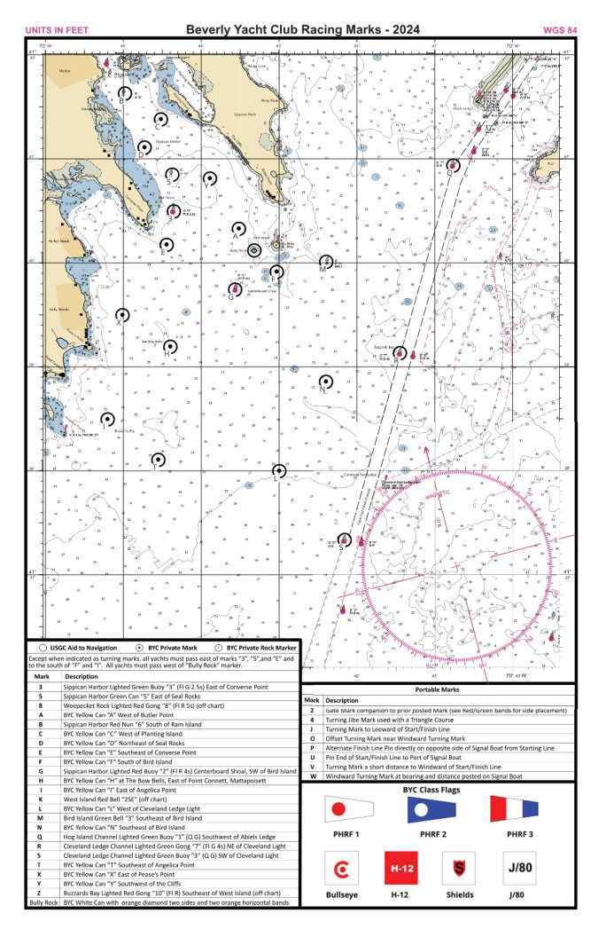
Mark Table – BYC Racing 2025
Mark locations are used to generate the headings and distances between marks for the purpose of setting racecourses. BYC racing marks have been placed as accurately as possible at the locations specified, however they may move and should not be relied on for navigation.

Mark | Description | Latitude (N) | Longitude (W)
2 | Portable Gate Mark Companion to Prior Posted Mark | Portable Mark
3 | Sippican Harbor Lighted Green Buoy “3” (Fl G 2.5s) East of Converse Point | 41° 40.50’ | 70° 44.40’
4 | Portable Turning Jibe Mark Used with a Triangle Course | Portable Mark
5 | Sippican Harbor Green Can “5” East of Seal Rocks | 41° 40.83’ | 70° 44.39’
8 | Weepecket Rock Lighted Red Gong “8” (Fl R 5s) (off chart) | 41° 31.82’ | 70° 43.43’
A | BYC Yellow Can “A” West of Butler Point | 41° 40.43’ | 70° 43.52’
B | Sippican Harbor Red Nun “6” South of Ram Island | 41° 41.61’ | 70° 45.00’
C | BYC Yellow Can “C” West of Planting Island | 41° 41.38’ | 70° 44.52’
D | BYC Yellow Can “D” Northeast of Seal Rocks | 41° 41.12’ | 70° 44.73’
E | BYC Yellow Can “E” Southeast of Converse Point | 41° 40.17’ | 70° 44.45’
F | BYC Yellow Can “F” South of Bird Island | 41° 39.92’ | 70° 43.03’
G | Sippican Harbor Lighted Red Buoy “2” (Fl R 4s) at Centerboard Shoal, Southwest of Bird Island | 41° 39.70’ | 70° 43.60’
H | BYC Yellow Can “H” at The Bow Bells, East of Point Connett, Mattapoisett | 41° 39.20’ | 70° 44.40’
I | BYC Yellow Can “I” East of Angelica Point | 41° 38.50’ | 70° 45.20’
J | Portable Turning Mark to Leeward of Start/Finish Line | Portable Mark
K | West Island Red Bell “2SE” (off chart) | 41° 34.10’ | 70° 48.80’
L | BYC Yellow Can “L” West of Cleveland Ledge Light | 41° 38.00’ | 70° 43.00’
M | Bird Island Green Bell “3” Southeast of Bird Island | 41° 40.00’ | 70° 42.37’
N | BYC Yellow Can “N” Southeast of Bird Island | 41° 38.86’ | 70° 42.40’
O | Portable Offset Turning Mark Near Windward Turning Mark | Portable Mark
P | Portable Alternate Finish Line Pin directly on opposite side of Signal Boat from Starting Line Pin | Portable Mark
Q | Hog Island Channel Lighted Green Buoy “1” (Q G) Southwest of Abiels Ledge | 41° 40.93’ | 70° 40.77’
R | Cleveland Ledge Channel Lighted Green Gong “7” (Fl G 4s) Northeast of Cleveland Light | 41° 39.12’ | 70° 41.45’
S | Cleveland Ledge Channel Lighted Green Buoy “3” (Q G) Southwest of Cleveland Light | 41° 37.33’ | 70° 42.12’
T | BYC Yellow Can “T” Southeast of Angelica Point | 41° 38.11’ | 70° 44.55’
U | Portable Pin End of Start/Finish Line to Port of Signal Boat | Portable Mark
V | Portable Turning Mark a Short Distance to Windward of Start/Finish Line | Portable Mark
W | Portable Windward Turning Mark at Bearing and Distance Posted on Signal Boat | Portable Mark
X | BYC Yellow Can “X” East of Pease’s Point | 41° 39.50’ | 70° 45.01’
Y | BYC Yellow Can “Y” Southwest of the Cliffs | 41° 40.81’ | 70° 43.89’
Z | Buzzards Bay Lighted Red Gong “10” (Fl R) Southeast of West Island (off chart) | 41° 34.61’ | 70° 43.25’
Bully Rock | White Cylinder with an orange diamond on two opposite sides and two orange horizontal bands. This mark is designated as an  obstruction for PHRF boats. | 41° 40.12’ | 70° 43.33’

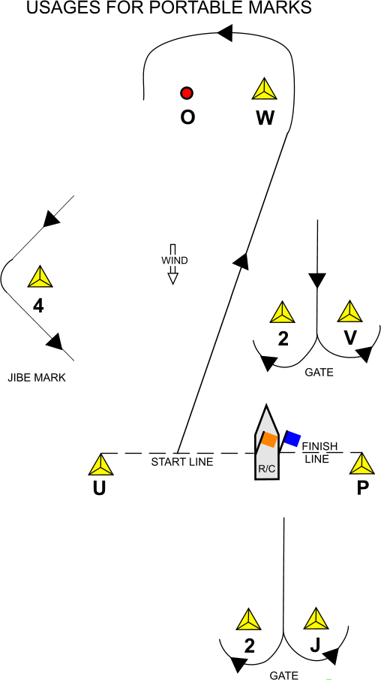
Sample Courses Using Portable Marks
WOV2WOP | Four legs: windward with offset / leeward with gate start at U finish at P
WO4UWOU | Five legs: triangle plus windward with offset / leeward start at U finish at U
XOA2E | Three legs: windward with offset / leeward with gate at A start/finish (middle) at E
HOAHOA | Four legs: windward with offset / leeward no gate 2 laps start at A finish at A
Note: Red bars should be placed under each course marker, as appropriate, except for gates. The Red and Green bars used with gate mark “2” and its companion depends on which side of the companion mark gate mark “2” is placed.

Common Race Signals/ Flags (Revised per RRS 2025-2028)
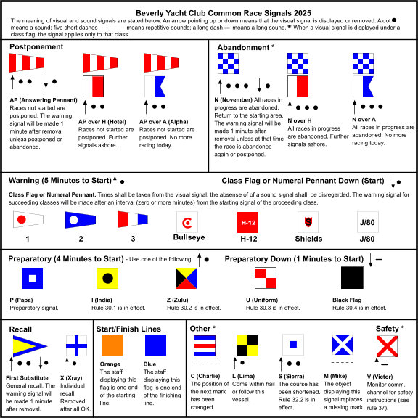

BYC Series Racing: Suggested Guidelines

Tuesday Twilight Series: Bullseyes & H-12s

First warning signal: 1800 hrs.
- Suggested starting order: Bullseyes then H-12s
- Preferred course: windward –leeward; however, the drop mark course diagram offers other options. Consult with fleet representatives if considering gates and offsets – these are used when a larger number of boats are sailing.
- Number of races: Two races for each class.
- Duration of races: approximately 40 – 60 minutes with legs of duration 10 to 15 minutes and approximately 0.3 nm to no more than 0.5 nm.
- Starting location – Sippican Harbor in the vicinity of BYC mark C or Y.
- August’s earlier sunsets should be considered while selecting courses.

Other requests:
- Communicate with the fleets on VHF CH 72
- Announce OCS (on the course side) sail numbers on VHF CH 72
- In heavier weather, both fleets will want a wind check before the start, especially the H-12s since wooden spars can break; if winds are steady 18-20 kts, they may decide not to race, especially with bigger seas and higher gusts.
- Consult with fleet reps as desired.

Wednesday Twilight Series: PHRF Racing

First warning signal: 1800 hrs.
- Suggested starting order: Class 1, Class 2, Class 3
- Starting location: vicinity of mark “G” or BYC mark “A”
- NOTE: Avoid marks “3” and “5”, BYC mark “E”, and Bully Rock area south of Bird Island. Also marks “F” and “I”.
- Number of races: One for each class
- Please communicate with the fleet on VHF CH 72.
- Please announce OCS (on the course side) sail numbers on VHF CH 72.
- Inform Cape Cod Canal Marine Traffic Control on VHF c.13, 14, or 16 if fleet will turn at or cross the Cleveland Ledge Channel (if marks “S,” “R,” or “Q” are used).

August’s earlier sunset should be considered when selecting courses.

CLASS 1 – Windward-Leeward Course – Wind/Distance Chart
SPRING and SUMMER until mid-August | WIND SP. | 5 -10 KT. | 10 - 16 KT. | *16 - 25 KT
SPRING and SUMMER until mid-August | DIST. | 6-7 nm | 8-10 nm | 10-11nm
SUMMER after mid-August | WIND SP. | 5 -10 KT. | 10 - 16 KT. | *16 - 25 KT
SUMMER after mid-August | DIST. | 5-6nm | 6-8nm | 9-10 nm
*Note: in flatter water, the distance for the 16-25 KT wind range can be slightly increased;
long courses should not be used in light air, particularly in August.

CLASSES 2 – Triangular Course – Wind/Distance Chart, see course listing for details

SPRING and SUMMER until mid-August | WIND SP. | 5 -10 KT. | 10 - 16 KT. | *16 - 25 KT
SPRING and SUMMER until mid-August | DIST. | 5-6 nm | 7-8 nm | 9-10 nm
SUMMER after mid-August | WIND SP. | 5 -10 KT. | 10 - 16 KT. | *16 - 25 KT
SUMMER after mid-August | DIST. | 4-5 nm | 6-8 nm | 8-9 nm
*Note: in flatter water, the distance for the 16-25 KT wind range can be slightly increased;
long courses should not be used in light air, particularly in August.

CLASSES 3 – Windward-Leeward – Wind/Distance Chart

SPRING and SUMMER until mid-August | WIND SP. | 5 -10 KT. | 10 - 16 KT. | *16 - 25 KT
SPRING and SUMMER until mid-August | DIST. | 4-5 nm | 6-7 nm | 8-9 nm
SUMMER after mid-August | WIND SP. | 5 -10 KT. | 10 - 16 KT. | *16 - 25 KT
SUMMER after mid-August | DIST. | 4-5 nm | 6-7 nm | 8-9 nm
*Note: in flatter water, the distance for the 16-25 KT wind range can be slightly increased;
long courses should not be used in light air, particularly in August.
Wednesday Twilight Example Triangle Courses
Suggestion is at least two weather legs, not more than two reach legs and downwind legs are welcome.
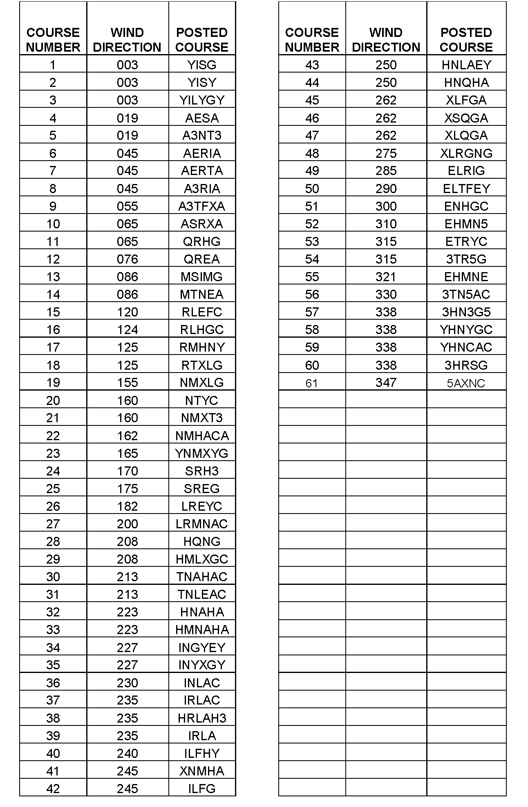

Thursday Ladies’ Series: Bullseyes and H-12s

First warning signal: 1400 hrs.
    - Suggested starting order: Bullseyes, then H-12s.
    - The fleets’ preferred course: windward-leeward; however, the drop mark course diagram offers other options. Consult with fleet representatives if considering gates and offsets – these are used when a larger number of boats will be sailing.
- Number of races recommended: Two for each class with the second race intended for crew helming. Skippers helming the second race are required to inform the Race Committee and she shall not be scored.
      - First race is skipper race (scored) – longer course.
      - Second race is crew race (scored) – shorter course.
      - Optional 3rd race for spinnaker practice (not scored; consult with fleet representatives before heading out).
    - Suggested courses:
      - RC should attempt to get the best marks for W/L course within Sippican outer harbor.
      - It is preferred not to cross the channel and to not use mark “5” as a turning mark.
    - Starting location:
      - Vicinity of BYC mark Y (in low to moderate SW wind),
      - or in vicinity of BYC mark C or D (on windy days 18+ kts).
- Desired duration of races:
  - 1st race: approx. 45 minutes.
  - 2nd race: approx. 30 minutes.
  - 3rd race: depends on how much time before Commodores has to dock and prepare for Thursday Twilight racing; finish near Nyes Wharf, but not in channel.

Other Requests:
    - Communicate with the fleet on VHF CH 72.
    - Announce OCS (on the course side) sail numbers on VHF CH 72.
    - In heavier weather, both fleets will want a wind check before the start, especially the H-12s since wooden spars can break; if winds are steady 18-20 kts, they may decide not to race, especially with bigger seas and higher gusts.

Thursday Twilight Series: J/80s, Shields

First warning signal: 1800, except for August 14, 21, and 28 when the first warning signal will be at 1730.

- Suggested starting order: Shields, then J/80s.
- Starting location: Anywhere North of, and including A, G, and E. Y is a common starting area.
- Number of races: Two races per class
- The fleets’ preferred course: windward-leeward; however, the drop mark course diagram offers other options, including the use of gates and offsets. The start/finish line can be established midway between the windward and leeward marks to allow a finishing leg to windward. This creates a 5-leg course but maintains the same distance as a start/finish line at the leeward mark.
- All fleets should sail W/L courses, 4 legs.

Other Requests:
    - Communicate with the fleet on VHF CH 72.
    - Announce OCS (on the course side) sail numbers on VHF CH 72.
    - The J-80 Fleet would appreciate a practice start in May and June, at 5:50 PM, if practicable.

Saturday Afternoon Series: Shields

NOTE: BYC marks 3 and 5 cannot be used for weekend racing because of harbor traffic. Race course legs cannot cross the navigation channel north of BYC mark 3 on weekends.

First warning signal: 1400 hrs., except on August 2, 2025, when the first warning signal will be at 1100 hrs. Racing on August 30, 2025, is a special event with its own Notice of Race and Sailing Instructions.

- No start after 1600 hrs.
- Number of races: two; NOTE: five races are slated to be held on Saturday, August 2.
- Starting location: Anywhere North of, and including A, G, and E.
- The fleet’s preferred course: windward-leeward; however, the drop mark course diagram offers other options, including the use of gates and offsets.
- Desired length: Longer races (not quick W-L)

Other Requests:
- Please communicate with the fleet on VHF CH 72.
- Please announce OCS (on the course side) sail numbers on VHF CH 72.

Sunday Afternoon Series: Bullseyes & H-12s
NOTE: BYC marks 3 and 5 cannot be used for weekend racing because of harbor traffic. Race course legs cannot cross the navigation channel north of BYC mark 3 on weekends.

First warning signal: 1400 hrs.
    - Suggested starting order: Bullseyes, then H-12s.
    - The fleets’ preferred course: windward-leeward; however, the drop mark course diagram offers other options. Consult with fleet representatives if considering gates and offsets – these are used when a larger number of boats will be sailing.
    - Number of races: Two per fleet.
    - Suggested courses:
      - RC should attempt to get the best marks for W/L course within Sippican outer harbor.
    - Starting location:
      - Vicinity of BYC mark Y (in low to moderate SW wind),
      - or in vicinity of BYC mark C or D (on windy days 18+ kts, see note below under Other Requests regarding wind conditions).
- Desired duration of races:
- 1st race: approx. 45 minutes.
- 2nd race: approx. 30 minutes.

Other Requests:
- Communicate with the fleet on VHF CH 72.
- Announce OCS (on the course side) sail numbers on VHF CH 72
- In heavier weather, both fleets will want a wind check before the start, especially the H-12s since wooden spars can break; if winds are steady 18-20 kts, they may decide not to race, especially with bigger seas and higher gusts.

Sunday Fall Series: Shields, Bullseyes, H-12s
NOTE: BYC marks 3 and 5 cannot be used for weekend racing because of harbor traffic. Race course legs cannot cross the navigation channel north of BYC mark 3 on weekends.

First starting sequence signal: 1030 hrs.
    - Suggested starting order: Shields, Bullseyes, then H-12s.
    - The fleets’ preferred course: short windward-leeward legs; however, the drop mark course diagram offers other options, including the use of gates and offsets.
    - Number of races recommended:
      - As many as possible – usually no more than 6.
      - Races are not officially scored through Regatta Network.
      - Daily prizes will be awarded on the Club deck after racing.
    - Suggested courses:
      - Short W-L courses, using drop marks.
    - Starting location:
      - Vicinity of BYC mark Y, C or D.

Other Requests:
- Communicate with the fleets on VHF CH 72.
- Announce OCS (on the course side) sail numbers on VHF CH 72
- In heavier weather, fleets will want a wind check before the start, especially the H12s since wooden spars can break; if winds are steady 18-20 kts, they may decide not to race, especially with bigger seas and higher gusts.

BYC Racing Safety Protocol
The most current version is posted each season on the BYC website at beverlyyachtclub.org/racing

The decision to hold a race or to postpone or abandon a race is the decision of the Principal Race Officer (see RRS 27.3 Other Race Committee Actions Before the Starting Signal, and RRS 32.1 Shortening or Abandoning After the Start). The decision to participate in a race or to withdraw is the decision of each boat captain (see RRS 3 Decision to Race).
On-the-Water Emergency Response
The obligation to assist a person or boat in danger is the first obligation of all boats and competitors (see RRS 1.1). The safety of participants is the priority; boats and property are secondary.
- In the event of an emergency on the water, call Commodores immediately on VHF CH 72.
- Participants should be aware that immediate assistance may not be available to them and, therefore, should be prepared to be self-reliant to the maximum possible extent for incidents such as Man Overboard, injuries, medical emergencies, equipment failures, etc.
- Although the Harbormaster is the most highly trained and capable first responder in an emergency, life sustaining measures may be needed prior to the Harbormaster’s arrival. All available means from participants and on-the-water race committee must be deployed.
- The Commodores driver will coordinate the response to a person or boat in danger until the Harbormaster has responded or the situation has been resolved. In the absence of life- threatening or serious injury, the Commodores driver will stand by as needed and make sure not to make the situation worse by possibly endangering other participants, volunteers, or staff.
- The Commodores driver will report every incident where a person or boat is in danger to the Harbormaster and BYC Base on VHF CH 16, or by cell phone if radio hails do not establish communications.
- In emergencies, if the Harbormaster cannot be reached on VHF CH 16, use 911.
- Where Commodores is unable to assist immediately, another race committee vessel or other boat on-scene can provide immediate assistance at the direction of the Commodores driver.
- Where a person needs emergency medical assistance, the Commodores driver will consult with the Harbormaster for direction on transfer of the person to Marion Fire / EMS.
- In the event of an on-the-water safety incident, the Commodores driver shall have responsibility for the safety of Commodores.
General On-the-Water Safety
- The PRO should designate an onboard assistant who will keep track of racing yachts visible from Commodores or visible from a race committee mark/safety boat if used.
- Except for Rockets, Lasers, Optimists and 420’s (dinghies), every competing boat is required to carry a VHF radio tuned to CH 72.
- In accordance with RRS 40.1 Personal Flotation Device, all participants in all BYC managed races shall wear properly fastened, USCG-approved personal flotation devices while racing, except for brief periods while changing clothing.
- If a boat retires from racing, it shall inform the race committee as soon as possible on CH 72 or by hailing the race committee alongside.

Additional Resources for Race Committee Volunteers
BYC Race Committee Contacts for 2025:
Fleet representatives:
Bullseye: Kathryn Collings - collings.marion@verizon.net
H12: Ellen Bowler - bowler.ellen@gmail.com
Tom Crowley – tom_crowley@att.net
J/80: Greg Nourjian - rgn@nourjian.com
PHRF: Ed Dailey - dailey@raptor205.com and Barry Steinberg - bmjb@comcast.net
Shields: Richard Robbins - robbins.richard@comcast.net
Rockets: Paul Bolick - paulbolick@gmail.com
Race volunteer captains:
Carolyn Petrie - carolyn.i.petrie@gmail.com
Susan Mead - semead@aol.com
Protest chair: Peter Quandt - protest@beverlyyachtclub.org
Scorer: Jenny Memoli - scoring@beverlyyachtclub.org
Race chair: Kenneth Deyett - race@beverlyyachtclub.org

US Sailing: https://www.ussailing.org
The Racing Rules of Sailing: US Sailing members can download the current Racing Rules from US Sailing’s website (https://www.ussailing.org/competition/rules-officiating/the-racing-rules-of-sailing-2025-2028/) or view them at https://d7qh6ksdplczd.cloudfront.net/sailing/wp-content/uploads/2024/07/05091216/RRS-2025-2028-Final.pdf as well as through the US Sailing Racing Rules of Sailing App available on your mobile device. Those serving aboard Commodores are encouraged to read Part 3: “Conduct of A Race.”

Race Management Certification: US Sailing offers Race Management seminars throughout the year, which is the first step in seeking certification.

If you are interested in pursuing the Race Management certification path, please contact BYC’s Race Committee Chair for further guidance.

