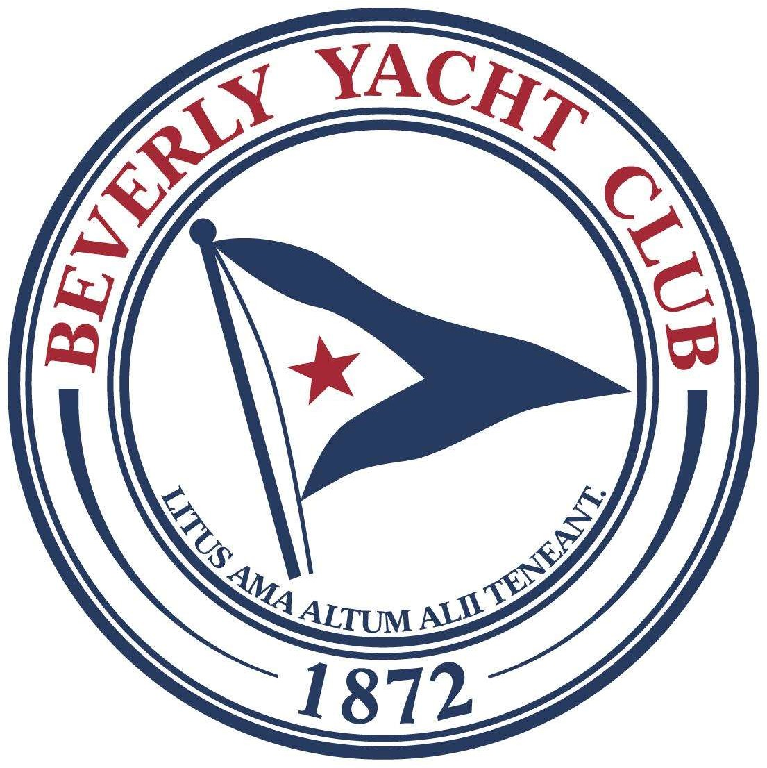

BYC 2025 HURRICANE CUP RACES
Saturday, September 20, 2025
Pursuit Race
Marion, Massachusetts 02738
The Organizing Authority (OA) is the Beverly Yacht Club (BYC)

SAILING INSTRUCTIONS
‘[DP]' means that rule may be subject to a discretionary penalty.
‘[NP]’ means that a boat may not protest another boat for breaking that rule. This changes RRS 60.1 (Right to Protest).
In the event of any conflict between the Notice of Race and the Sailing Instructions, the Sailing Instructions will prevail.

RULES
RRS 60.4 (a) (2) is changed as follows: “if it alleges a breach of a rule of Part 2 or RRS 31 and is from a boat that was not involved in and did not see the incident, or.”

CHANGES TO SAILING INSTRUCTIONS
  - Any changes to the sailing instructions or schedule will be posted at least 24 hours prior to the first scheduled warning signal, on the Official Notice Board at https://https://www.regattanetwork.com/event/29035 courtesy copies may be posted on the bulletin board on the BYC porch.
  - Changes to the Sailing Instructions may be made on the water by the Race Committee on the boat prior to the warning signal and after displaying signal flag “L” and a radio announcement by the Race Committee on VHF CH 72.

COMMUNICATIONS WITH COMPETITORS
  - Notices to competitors will be posted on the Official Notice Board per 2.1 above.
  - Scratch sheets including start times will be available through the registrant’s email and at the BYC bar, no later than 0900 on the day of the race.
  - On the water, the Race Committee intends to monitor and communicate with competitors on VHF CH 72.
  - [DP] While racing, except in emergency, a boat shall not make voice or data transmissions and shall not receive voice or data communication that is not available to all boats.

CODE OF CONDUCT
[DP] Competitors and support persons shall comply with reasonable requests from the race officials.

SIGNALS MADE ASHORE
  - Signals made ashore will be displayed from the BYC flagpole.
  - When flag AP is displayed ashore, ‘1 minute’ is replaced with ‘not less than 60 minutes’ in Race Signals AP.

SCHEDULE OF RACE
The first warning signal for the Pursuit Race will be at 1155.

RACING AREA
The racing area is outer Sippican Harbor and Buzzards Bay as show in Addendum 1.

COURSES
The selected course will be displayed on the course board on the race committee boat prior to the first warning signal.

MARKS
  - Marks are described on the attached Beverly Yacht Club Race Marks - 2025 chart in the Notice of Race.
  - Except when indicated as rounding marks, all racing boats shall pass to the east of marks “5”, “3” and “E” and to the south of marks “F” and “I”. All yachts must pass west of the Bully Rock marker.

START AND RECALLS
  - The start will be in the vicinity of Sippican Harbor Lighted Red Buoy “2” (FL R) at Centerboard Shoal (BYC mark “G”).
  - Boats will be allocated a start time relative to their handicap and those times will be listed on the scratch sheet (along with marks for courses A, B or C).
  - The first boat(s) to start will be allocated 1200 and will start in accordance with RRS
26. (5-minute warning, 4-minute preparatory signal, 1 minute signal, start).
  - The subsequent boats will not have a preparatory warning or a 1-minute warning prior to her start. The Race Committee will try to announce on VHF CH 72 a 1-minute warning along with her boat name but will not be obligated to do so. Her starting signal will be the start time on her scratch sheet and announced with a single horn.
  - Boats waiting to start must keep clear of boats that are starting.
  - A boat that does not start within 10 minutes of its designated start time will be scored DNS without a hearing and such a score shall not be grounds for redress.

POSTPONING PURSUIT RACE
  - Postponement of pursuit races shall be in accordance with RRS 27.3.
  - In the event of postponement, the starting minutes allocated will remain the same. Yachts will start at their allocated number of minutes after the rescheduled start time. The start sheet will not be reprinted. Yachts will be advised of the rescheduled start time via VHF CH 72.

INDIVIDUAL RECALLS
  - Boats starting early by one minute or more shall have that amount of time added to her elapsed time and then a further 10% elapsed time penalty added. No recall signal shall be made. This changes RRS 29.1.
  - Boats starting early by less than one minute: The race committee shall promptly display code flag 'X' accompanied by one sound signal. The flag will be displayed for a period of 30 seconds or until all such boats have completely returned to the pre-start side of the line by rounding one of the ends, whichever is earlier. A 10% elapsed time penalty shall apply to boats that fail to return to the pre-start area and start correctly. This changes RRS 29.1.

FINISHING
  - The finish line will be between the staff from which a blue flag is displayed on the Race Committee finish boat and BYC mark “Y”.
  - If the Race Committee is absent when a boat finishes, she shall report her finishing time and her position in relation to nearby boats, by texting the BYC scorer at 508-944- 3157 at the first reasonable opportunity.

PENALTIES
  - RRS Appendix V will apply in its entirety.
  - All post-race penalties must be taken before the protest time limit regardless of whether a protest was filed. This changes RRS V2(a).

TIME LIMITS
The Hurricane Cup Pursuit Race has a time limit of five (5) hours from the start of the first boat.

PROTESTS AND REQUESTS FOR REDRESS
  - Protests and requests for redress shall be written on hearing forms available in the BYC Protest Box located on the wall to the left of the clubhouse door to the porch and from US Sailing. The form should be completed, photographed or completed electronically, and emailed to protest@beverlyyachtclub.org within two hours from the time the Race Committee finish boat returns to BYC. The RC docking time will be posted on the Notice Board.
  - Notices will be posted and emailed no later than 1800 on September 21, 2025 to inform competitors of hearings in which they are parties or named as witnesses and the time and location of that hearing.
  - A boat requesting redress based on her score shall do so by 1100 on September 21, 2025. This changes RRS 62.3.

SAFETY
  - [DP] When code flag “L” is displayed on the Race Committee signal boat before a warning signal, boats shall check in by sailing past the signal boat on starboard tack and hailing their numbers until acknowledged by the race committee.

  - Every competing boat is required to carry a VHF radio and monitor VHF CH 72 from the time of the preparatory signal and while racing.
  - A boat that retires shall notify the Race Committee by VHF, or by calling the BYC PRO at 215-531-2959 at the first reasonable opportunity.

RISK STATEMENT
RRS 3 states: “The responsibility for a boat’s decision to participate in a race or to continue racing is hers alone.” By participating in this event each competitor agrees and acknowledges that sailing is a potentially dangerous activity with inherent risks. These risks include strong winds and rough seas, sudden changes in weather, failure of equipment, boat handling errors, poor seamanship by other boats, loss of balance on an unstable platform and fatigue resulting in increased risk of injury. Inherent in the sport of sailing is the risk of permanent, catastrophic injury or death by drowning, trauma, hypothermia, or other causes. The organizing authority will not and does not accept any liability for material damage or personal injury, or death sustained in conjunction with, or prior to, during or after racing.

ADDITIONAL INFORMATION
Competitors may contact the following individuals for additional information:
BYC Event Chair: Katie Hall katie_hall@hotmail.com

BYC Race Chairman: Ken Deyett racing@beverlyyachtclub.org

PHRF Fleet Representative: Ed Dailey ejdnetwork@gmail.com

